TASK 1

#include <iostream>

using namespace std;

int main() {

int i, array [10];

cout<<"Enter the integers"<<endl;

for(i=0;i<10;i++){

cin>>array [i];

}

cout<<"You entered these integers"<<endl;

for(i=0;i<10;i++){

cout<< array [i]<<"\t";

}

return 0;

}

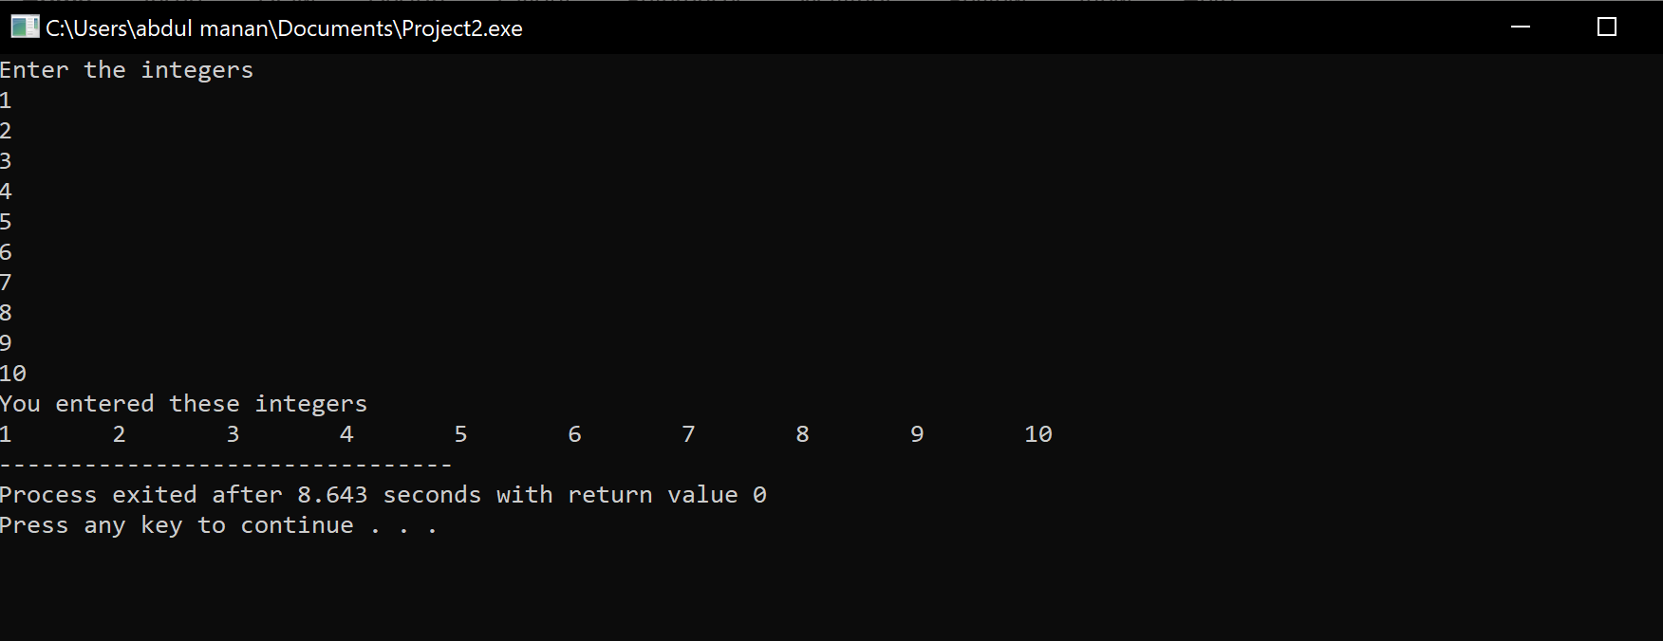

TASK 2

#include <iostream>

using namespace std;

int main() {

int i, array [5], sum=0 ,multiply=1;

cout<<"Enter the integers"<<endl;

for(i=0;i<5;i++){

cin>>array [i];

}

cout<<"sum is: "<<endl;

for(i=0;i<5;i++){

sum+= array [i];

}

cout<<"product is: "<<endl;

for(i=0;i<5;i++){

multiply\*= array [i];

}

cout<<sum<<endl;

cout<<multiply<<endl;

return 0;

}

TASK 3

#include <iostream>

using namespace std;

int main() {

int n;

cout << "Enter the size of the diamond : ";

cin >> n;

char array[n][n];

for(int i = 0; i < n; i++) {

for(int j = 0; j < n; j++) {

array[i][j] = ' ';

}

}

for(int i = 0; i < n/2+1; i++) {

for(int j = n/2-i; j <= n/2+i; j++) {

array[i][j] = '\*';

}

}

for(int i = n/2+1; i < n; i++) {

for(int j = n/2-(n-i-1); j <= n/2+(n-i-1); j++) {

array[i][j] = '\*';

}

}

for(int i = 0; i < n; i++) {

for(int j = 0; j < n; j++) {

cout << array[i][j] << " ";

}

cout << endl;

}

}

